(UPCAP) provides Special Education mediation, facilitations, and training at no cost for Delta, Baraga, Dickinson, Gogebic, Houghton, Iron, Keweenaw, Menominee, Ontonagon, Schoolcraft Count(y)ies' schools and residents through the Special Education Mediation Program (SEMS). These services are federally funded through the Individuals with Disabilities Education Act and paid for by a grant from the Michigan Office of Special Education. 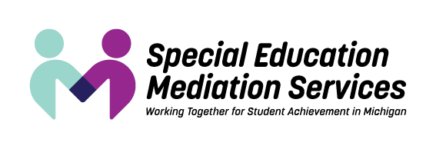
​SEMS provides services in the earliest stages of intervention and educational planning and beyond:

Meeting Facilitation. Facilitation can help the parties develop the best intervention plan or educational program for the circumstances. A neutral facilitator helps the participants work through communication issues so the participants can focus on and resolve the issues.
​
Mediation. Mediation aids the parties in resolving disputes that may arise between families of students with disabilities and schools. Mediation is voluntary and confidential. The neutral mediator fosters a cooperative discussion. The parties alone make the final decisions. A successful mediation can result in a written, signed agreement that can be incorporated into an IFSP or IEP.
​
Training. Learning collaborative communication and dispute resolution techniques can make parents, educators, and service providers more effective in planning and decision making. Workshops can be adapted to the needs of organizations, staff, or parent groups.
​
Outreach. The more people know about facilitation and mediation services, the more they can benefit from them. Presentations can be made around the state, supported by materials that explain the benefits of collaborative methods.

For more information please call 833-KIDS1ST or 833-543-7178 or visit: https://www.mikids1st.org. Requests for services are processed through the SEMS central office with local service delivery coordinated with (UPCAP).

