Expanding Energy Waste Reduction Opportunities in Michigan’s Upper Peninsula
December 2018
Prepared by
Public Sector Consultants
Lansing, Michigan
www.publicsectorconsultants.com
Prepared for
Upper Peninsula Commission on Area Progress
Escanaba, Michigan
www.upcap.org

Table of Contents
Table of Contents 3
Background 4
Current EWR in the U.P. 4
Energy Savings Potential 8
Process for Assessing Potential Portfolio/Program improvements 9
Best Practices 9
Impact on Cost and Savings 11
Stakeholder Input 11
Path Forward 14
APPENDIX A: Portfolio-level Strategies 17
Uniform Program Design and Requirements 17
U.P.-focused Trade Ally Network 17
Smart Purchasing (Bulk Buying and/or Competitive Bidding) 18
Centralized Planning, Management, and Evaluation 19
Leveraged Investment 19
APPENDIX B: Program Strategies 20
Residential Programs 20
Commercial and Industrial Programs 28
Overall Cost and Savings 32

Background
At the request of the Michigan Agency for Energy—Michigan Energy Office, Public Sector Consultants (PSC) has developed a proposed energy waste reduction (EWR) plan for Michigan’s Upper Peninsula (U.P.). PSC worked with the Upper Peninsula Commission on Area Progress to identify current characteristics of EWR programs in the U.P. and to gather stakeholder input throughout the development of this plan. This plan considers the historical success of EWR programs, the energy-efficiency potential of the U.P., best practices in program design and implementation, and opportunities for enhancing program efficacy through coordinated delivery activities. The plan is designed as a starting point for conversations between U.P. stakeholders, including utilities, program implementers, local government representatives, businesses, residents, and others, to identify ways to increase potential benefits of EWR program portfolios by capturing delivery efficiencies, expanding the reach of existing and future programs, and leveraging the local EWR investments.
The report includes the following elements:
- Background that includes an overview of the current EWR portfolios of the U.P. utilities, including program mix and recent performance and future estimates of EWR potential
- Description of the process for analyzing potential enhancements in program delivery to reduce cost, increase savings, and expand program reach
- Recommendations for a process to explore and implement program enhancements
Appendices provide additional detail around portfolio strategies that could be employed based on recognized best practices as well as program-specific opportunities to increase savings, reduce cost, or expand program reach.

Current EWR in the U.P.
The U.P. is home to 19 electric suppliers and four natural gas suppliers. U.P. utilities have been delivering energy-efficiency programs since 2008 in compliance with Public Act (PA) 295, the Clean, Renewable and Efficient Energy Act of 2008, and now PA 342 of 2016, the Clean and Renewable Energy and Energy Waste Reduction Act., These statutes require, among other criteria, that utilities achieve electric energy savings equal to 1 percent of their annual sales and natural gas savings equal to 0.75 percent of annual sales. Most utilities in the U.P. deliver programs through one of two implementation contractors—Efficiency UNITED and the Michigan Electric Cooperative Association (MECA), with just a few exceptions.
In 2009, the Michigan Public Service Commission (MPSC) selected Michigan Community Action and CLEAResult (operating as Efficiency UNITED) as the state energy optimization plan administrator through a competitive process. Funding program delivery by the administrator provides an optional path for utilities to comply with PA 295, amended by PA 342. Utilities opting for this alternate compliance path make a payment of 2 percent of revenue to the plan administrator. Currently, Efficiency UNITED is implementing programs for one electric and one dual-fuel investor-owned utilities and six municipal utilities as the state plan administrator.
In addition, Efficiency UNITED contracts directly with one investor-owned gas utility provider and one investor-owned electric utility provider in the U.P. to implement programs. The MECA (operating as the MECA Collaborative) contracts with the Wisconsin Energy Conservation Corporation to implement programs on behalf of 13 electric utilities across Michigan, including three cooperative utilities and eight municipal utilities in the U.P.
In 2016, utility programs in the U.P. achieved electric savings of nearly 43 million kilowatt-hours (kWh), including approximately 2.5 million kWh in self-directed savings. These savings represent 134 percent of the annual target. Exhibit 1 shows savings for utilities served by Efficiency UNITED in grey and for utilities that are part of the MECA Collaborative in yellow. The savings shown include market transformation bonuses, which are savings multipliers designed to encourage promotion of emerging technologies. The market transformation bonuses, which, for some utilities, accounted for over 35 percent of the 2016 savings targets, no longer count toward EWR goals (Art Thayer, pers. comm.). The MPSC disallowed market transformation bonuses beginning in 2018 as part of the transition from PA 295 to PA 342, as requirements for utility integrated resource planning places more emphasis on actual energy savings (Karen Gould, pers. comm.)

Exhibit 1: Annual Savings Achievement by Utility (by Megawatt-hours (MWhs) and Percentage of Target Achieved)
Utility Key
A | Alger Delta Cooperative Electric Association | K | Negaunee Department of Public Works
B | Village of Baraga | L | Newberry Water and Light Board
C | Bayfield Electric Cooperative | M | City of Norway
D | Cloverland Electric Cooperative | N | Ontonagon County Rural Electrification Association
E | City of Crystal Falls | O | City of Stephenson
F | Daggett Electric Department | P | Upper Peninsula Power Company
G | City of Escanaba | Q | City of Wakefield
H | City of Gladstone | R | Wisconsin Electric Power Company*
I | Village of L'Anse | S | Wisconsin Public Service Corporation*
J | Marquette Board of Light and Power | T | Xcel Energy**
Sources: Efficiency UNITED. n.d. 2016 Annual Report. Accessed February 1, 2018. https://www.michigan.gov/mpsc/0,4639,7-159-52495_53472_53476-292333--,00.html; Michigan Electric Cooperative Association. June 30, 2017. Collaborative Energy Optimization Annual Report for 2016. Lansing: Michigan Electric Cooperative Association.
* Now operating as Upper Michigan Energy Resources Corporation (UMERC)
** Formerly Northern States Power Company—Wisconsin
Efficiency UNITED delivers gas programs for Wisconsin Public Service and Xcel Energy as the statewide administrator and contracts directly with SEMCO Energy. Efficiency UNITED reports on savings achievement for utilities opting to utilize the statewide administration. SEMCO Energy and DTE Energy report their savings at a statewide level. At the request of the MPSC, both SEMCO Energy and DTE Energy provided total natural gas sales and savings achieved in their U.P. service areas. Exhibit 2 shows the targets and reported customer savings in hundreds of cubic feet (Ccf) for the natural gas utilities in the U.P. All of the utilities exceed their targets by a substantial amount. Overall, natural gas savings were nearly five times the targeted amount. For Wisconsin Public Service and Xcel Energy, utilities for which program-level details are available, over 90 percent of natural gas savings were achieved with commercial and industrial customers.
Exhibit 2: 2016 Savings and Targets for Natural Gas Utilities Operating in the U.P.

Source: Efficiency UNITED. n.d. 2016 Annual Report. Accessed February 1, 2018. https://www.michigan.gov/mpsc/0,4639,7-159-52495_53472_53476-292333--,00.html; SEMCO and DTE Energy pers. comm.
Efficiency UNITED and the MECA Collaborative provide similar program offerings. Program names and qualifying measures vary somewhat between implementers, and in some cases, between utilities; however, the overall structure of the program portfolios and the savings by program are consistent. For example, the commercial and industrial programs deliver over half the savings for both implementers, and high-efficiency product programs deliver the most savings for the residential sector. Exhibit 3 shows 2016 savings and spending by program category for both implementers. Savings and spending are generally aligned, although some programs have higher costs relative to savings, e.g., income-qualified and residential equipment and envelope upgrades. The high-efficiency products and commercial and industrial programs have the lowest relative cost of delivery. The high-efficiency products program delivered 29 percent of 2016 savings and accounted for 23 percent of spending, and over half of the residential sector savings. The programs targeted to businesses (commercial, industrial, and institutional entities) delivered over half of the portfolio savings (55 percent) and accounted for 46 percent of the combined program budgets.
Exhibit 3: Annual Savings and Spending by Program Category (MWhs and Thousands of Dollars)

Sources: Efficiency UNITED. n.d. 2016 Annual Report. Accessed February 1, 2018. https://www.michigan.gov/mpsc/0,4639,7-159-52495_53472_53476-292333--,00.html; Michigan Electric Cooperative Association. June 30, 2017. Collaborative Energy Optimization Annual Report for 2016. Lansing: Michigan Electric Cooperative Association.

Energy Savings Potential
The availability of low-hanging fruit, i.e., low-cost, easy-to-implement energy-efficiency measures, and advantageous policies, including market transformation bonuses, have supported utilities meeting and exceeding energy-efficiency targets since the inception of PA 295 and its amendment by PA 342.
Going forward, significant energy savings opportunities exist, but will require a strong delivery infrastructure, an engaged customer base, and support from local stakeholders and agencies to continue successful delivery of energy savings. Further challenging energy savings is the fact that energy services in the U.P. are complicated by a number of factors: the vast geography, low population density, and the diversity of energy suppliers.
Pursuing EWR potential stands to benefit both utility providers and their U.P. customers. The achievable energy-efficiency potential identified in the U.P., if captured, could create net benefits of over $137 million by 2026. The potential net benefits are the difference between projected net present value (NPV) of the costs avoided by not having to supply energy, estimated at $215 million, and the NPV of the costs to deliver programs (i.e., administration, marketing and outreach, technical assistance, incentives), estimated at $78 million.
Expanding program reach and/or reducing the cost of delivering programs both can increase the already substantial net benefits to U.P. residents and businesses. Exhibit 4 shows the potential net benefits to the U.P. under three scenarios: Business as Usual (achieving the 1 percent savings target annually); All Achievable Potential (considered an aggressive scenario in this analysis); and a Strategic Portfolio scenario that envisions potential cost savings and opportunities for expanded impacts from focus on hard-to-reach customers and new technology applications. The Business as Usual scenario represents savings of 1 percent of annual sales and investment of 1.7 percent of annual revenue. The Strategic Portfolio scenario achieves annual savings of 1.2 percent of annual sales and requires investment of 2 percent of annual revenue. The All Achievable Potential scenario requires investment of 3 percent of annual revenue to capture savings of 1.7 percent of annual sales. All three scenarios are cost-effective, but the Strategic Portfolio scenario has the highest benefit-cost ratio.
Exhibit 4: Net Benefits in Alternate Scenarios
Sources: Data compiled from PSC analysis as well as Efficiency UNITED and MECA Collaborative EWR plans filed with the Michigan Public Service Commission; GDS Associates. August 9, 2017. Upper Peninsula Energy Efficiency Potential Study Final Report. Accessed September 1, 2017. https://www.michigan.gov/mpsc/0,4639,7-159-80741---,00.html

Process for Assessing Potential Portfolio/Program improvements
To assess the opportunities for enhancing EWR programs in the U.P., and to develop strategic portfolio, PSC conducted three primary activities: a review of best practices; an assessment of impact on costs and benefits of adoption of recommended strategies; and collection of stakeholder input through forums and a survey.

Best Practices
This study examined strategies that would enhance delivery of EWR programs in the U.P., lower costs for service providers and participants, and more effectively reach customers that are historically underserved by energy-efficiency programs. In addition to a general review of best practices, strategies for reaching diverse customers over a large geographic area were examined. Five key areas for strengthening the programs offered were identified:
- Uniform program design and requirements. Variation in utility program designs can create confusion for end-users, market actors, and others. Each utility and their customers have unique characteristics, but small variations in measure offerings, rebate levels, or application requirements are more likely to impede participation than to meet specific or unique needs of a utility’s customers. Uniform program design allows for accelerated adoption of best practices.
- A U.P.-focused trade ally network. A fully developed and trained trade ally network creates significant value by decreasing administrative costs, increasing quality and realization of energy savings, and increasing overall customer engagement and satisfaction.
- Bulk purchasing or competitive bidding for key energy-efficiency technologies or measures. In each market sector, there are technologies or measures that account for a significant portion of the energy-efficiency potential. Driving down the cost of these technologies can greatly increase overall cost-effectiveness of the utilities’ program portfolios and reduce customer investment requirements. This approach can also be used for introduction of emerging technologies that often have higher costs until a certain market saturation is achieved.
- Centralized planning, management, and evaluation. Coordinated planning efforts, delivery support, and monitoring evaluation can reduce the cost burden and improve the effectiveness of each of these functions.
- Leveraged investment. Federal and foundation grants to advance clean energy options can help extend the impact of utility and customer EWR investments. Michigan, especially the U.P., has been underrepresented in historical awards of some of these funding opportunities; for example, Michigan has over 4 percent of the nation’s rural population, but has received less than 2 percent of the funding distributed through the Rural Energy for America Program. This is but one notable example of available funding that could be more fully utilized.
As shown in Exhibit 5, these strategies are interdependent and collectively support program efficiency and efficacy and can help to ensure program participation opportunities for all customers.
Exhibit 5: Portfolio Strategy

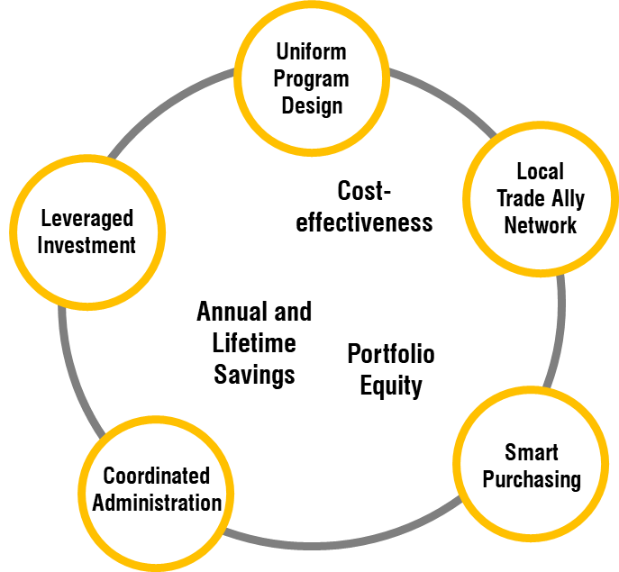
Source: Public Sector Consultants

Impact on Cost and Savings
Adoption of these best practices will affect program impacts and program delivery costs. Using data from the utilities’ EWR plans, annual performance reporting, and the statewide and U.P EWR potential studies commissioned by the MPSC, PSC examined impacts of:
- Modest reductions in selected measure costs—particularly for measures that are directly-installed, or measures promoted using upstream or midstream tactics where strategic sourcing could yield negotiated price reductions
- Investments in program delivery infrastructure that would increase customer awareness and improve participation experiences—these include: research to determine energy consumption characteristics, applicability of energy-efficient technologies, barriers to investment in EWR faced by U.P. residents and businesses, and programmatic strategies to address those barriers; expanded education and outreach efforts; and development of centralized portal that serves a single sources of program information and access
- Increased penetration for measures with additional potential—this includes 1) measures that represent lost-opportunities, i.e., these are measures that like heating or water heating equipment where if high-efficiency is not selected upfront, the opportunity for savings is no longer available until it is time to replace the equipment again and 2) increased participation by customer groups previously not reached through the programs
There are counteracting effects of these modifications to the existing program portfolios, e.g., reductions in per-unit measure costs would be offset by increased measure adoption. Likewise, the upfront investments in program delivery infrastructure should yield efficiencies in program administration and delivery. PSC examined the both the benefit and cost impacts of modifications to the programs offered in the U.P. over a ten and 20-year program horizon and calculated levelized cost of conserved energy and benefit-cost ratios from the utility/program administrator perspective. PSC looked at both a scenario that would achieve the current 1 percent savings target at the lowest cost as well as a scenario that sought to maximize the impact of an EWR investment equal to 2 percent of utility revenue. In both cases, PSC also looked at program portfolios that provide all customers the opportunity to participate. This analysis is shown in Appendix B.

Stakeholder Input
Throughout the development of the proposed U.P. EWR plan, UPCAP led facilitation of stakeholder input with assistance from PSC. Input was sought through a series of discussion forums hosted by UPCAP as shown in Exhibit 6.
Exhibit 6: Stakeholder Engagement
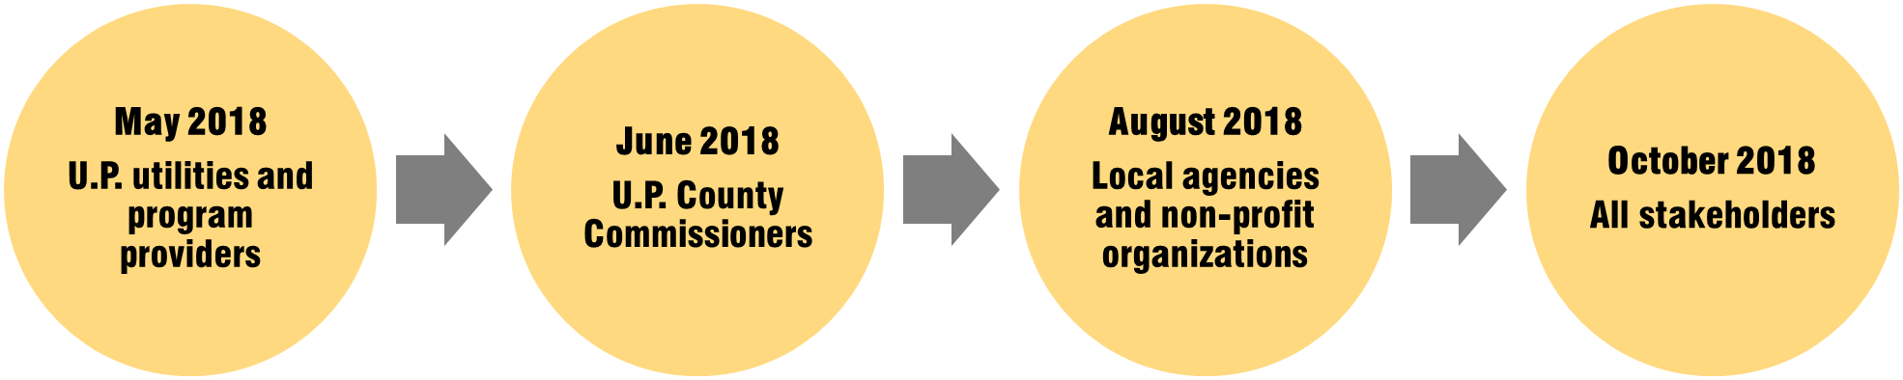
The U.P. utilities and program administrators described their significant accomplishments and the challenges faced to deliver programs throughout the U.P. They described efforts that are targeted to ensure that statutory savings goals are met while staying with historical spending thresholds. Other stakeholders commended the program efforts but noted gaps in program awareness and availability, illustrated in the following comments:
“Programs are good, but only a fraction of people know about them.”
“Retailers and contractors don’t promote the programs unless you ask about them.”
“Not clear what the first step is or who to contact to participate in programs.”
Stakeholders unanimously expressed interest in having input in the design of programs in order to represent the needs of their constituencies and to help ensure programs addressed those needs.
In addition to the discussion forums, PSC conducted a survey of key stakeholders including county commissioners, members of agencies and organizations that represent customers groups or support the implementation of EWR programs. The survey results echoed feedback shared in the forums. As shown in Exhibit 7, stakeholders were had higher awareness of programs offered for residents. Less than 40 percent said they were very or somewhat aware for the programs offered for businesses and industry.
Stakeholders were also asked about their perceptions of the awareness of residents and businesses of the available programs and services. Stakeholders estimated less than one-quarter of residents and businesses has any awareness of programs.

Exhibit 7: Stakeholder Awareness of Programs

Source: Source: PSC survey of local government and non-profit agency staff in the U.P. (n=32)
Exhibit 8. Resident and Business Awareness of Programs

Source: PSC survey of local government and non-profit agency staff in the U.P. (n=32)
When asked about what factors made it difficult for U.P. residents and businesses to pursue EWR opportunities, three-quarters of respondents indicated that lack of knowledge was a primary deterrent as shown in Figure 9. Long payback periods and higher cost of energy-efficient technologies were identified as barriers by 44 percent and 31 percent of respondents respectively. Availability of energy-efficient technologies and skilled contractors to install those technologies was not seen as a significant barrier.

Exhibit 9. Barriers to Investment in Energy-efficient Technologies

Source: PSC survey of local government and non-profit agency staff in the U.P. (n=32)
Stakeholders offered the following suggestions to enhance the current program offerings:
More PR [public relations] in newspapers, radio talk shows, and flyers.
Better communication between energy company and consumer; more face-to-face presentations.
More transparency and more localized efforts to educate utility customers as on how to take advantage of rebates/ programs/etc.
These recommendations align with recommendations resulting from the best practices review conducted by PSC. The process of program participation begins with program awareness and builds from there. Once customers become aware of programs, they need a relative easy process to turn their knowledge into action.

Path Forward
Robust EWR programs will provide significant benefits to the U.P. residents, businesses, and industry; investing in EWR at the Strategic Portfolio Level delivers significantly increased benefits to the U.P at a comparatively small incremental cost. Building on the success of the EWR programs to date, focused program enhancements can lower cost, improve program applicability and accessibility, and ensure that all residents of the U.P. have continued opportunities to participate.
Implementing recommended strategies for enhancing EWR programs in the U.P. will require enhanced collaboration amongst utilities and program administrators and other stakeholders. This will include a coordinated process for program design, monitoring of program implementation, identification of research or evaluation to support decision making, and development of consistent messaging and outreach strategies. First and foremost, this process should keep the needs and preferences of U.P. residents and businesses in mind.
The statewide EWR collaborative has been successful in bringing together a broad range of stakeholders each month. This group has been effective in identifying new EWR opportunities, sharing best practices, gathering input from multiple perspectives, engaging market actors and helping to move Michigan from the bottom quartile on the American Council for an Energy-Efficient Economy State Scorecard in 2008 to number 11 in 2016 and 2017., While this collaborative effort has served the state as a whole, the U.P. may not be fully represented. Program administrators and utility representatives from the U.P. attend collaborative meetings in-person or by phone. However, other stakeholders are unable to participate, and the agenda is not focused on issues most important to the U.P.
Establishment of a U.P.-focused collaborative process is recommended. The U.P. EWR collaborative would meet periodically with the objective of instituting strategies that: address barriers to investment in EWR that are specific to the U.P.; maximize net benefits; ensure program participation options for all U.P. residents and businesses; effectively meet the resource needs; and attract available funding and investment to advance EWR.
While program uniformity has significant benefits in terms of consistency in implementation processes and customer expectations, it is necessary to balance those benefits against the diversity of customer needs and preferences. The collaborative process should provide a forum for determining which program strategies will work best for U.P. customers based on a clear understanding of needs and preferences. Figure 10 shows a process that the U.P. EWR collaborative could follow to develop and deploy an enhanced or optimized program portfolio. This process could terminate in the development and launch of a plan or could be an iterative process informed by periodic evaluation of program performance. The iterative process supports continuous improvement of program based on lessons learned through program implementation and adaptation to changing market conditions.
Exhibit 10. Collaborative Process for the U.P. EWR Collaborative
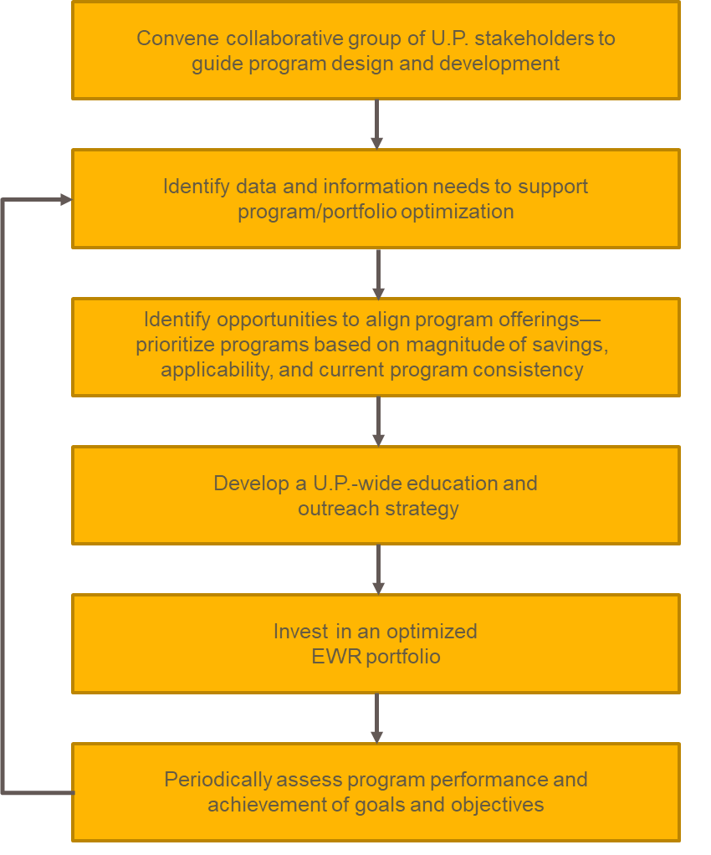
Source: Public Sector Consultants
The U.P. benefits from the number of engaged stakeholders committed to a successful EWR initiative to support affordable, clean, and reliable energy resources for the region. The utilities and program implementers bring a wealth of knowledge and program experience, both in the U.P. and throughout the state. Combining the commitment and resources of these groups to intentionally design and develop programs for U.P. customers, using a process that has demonstrated success for state as a whole, will ensure realization of the substantial benefits available from reduced energy waste.

APPENDIX A: Portfolio-level Strategies
The proposed plan for administration of EWR programs uses five portfolio-level strategies to reduce program cost, improve customer experience, attract trade allies, and maximize program impacts. Because these strategies relate to increased coordination, consistency, and leveraging of resources, expanded collaboration between utilities and service providers is required to deploy these strategies. Expected impacts are described in this section.

Uniform Program Design and Requirements
The current program offerings from Efficiency UNITED and the MECA Collaborative, the two program implementers operating in the U.P., have several common elements. However, even nuanced differences between providers can be difficult for different market actors to navigate. Each of the two primary implementers have different incentive levels and different application requirements for many of the same measures.
For example, customers currently served by the MECA Collaborative may receive a $75 incentive for a Wi-Fi-enabled thermostat or an occupancy-sensing smart thermostat. Customers get this incentive by submitting an application along with documentation of purchase price, manufacturer, and model number by mail. Customers of neighboring utilities where Efficiency UNITED is the implementer can get a $15 rebate for a programmable thermostat or $70 for a Wi-Fi-enabled thermostat. Along with the documentation required by the MECA Collaborative utilities, Efficiency UNITED customers must submit a copy of their electric bill.
On the commercial and industrial side, each of the implementers publishes an annual catalog that lists all measures qualifying for prescriptive, or set, incentives. While there are some similarities between the two catalogs, there are numerous differences in measure descriptions, required efficiency levels, and incentives offered, which again, can be difficult for trade allies and businesses operating across utility service territories to discern. This can result is dissatisfaction from customers expecting a certain incentive that may be different or even nonexistent depending on their utility’s program mix. Trade allies that work across service areas must account for these program differences when promoting and designing solutions for customers. Customers may have sites in different utility service territories, requiring similar tracking and differentiation, or if the trade ally or customer make a mistake during document submission, the application for incentives can be delayed several weeks. Creating common program designs will reduce frustration for customers and trade allies and may help to increase participation. It can also help to reduce the cost of administering programs.

U.P.-focused Trade Ally Network
There are significant gaps in the network of trade allies needed to effectively deliver energy-efficient technologies and services to residents and businesses in the U.P. Trade allies play a critical role in the success of program implementation, especially related to more comprehensive, long-life measures such as heating and cooling systems, industrial process equipment, and other technologies that require professional installation and/or commission to operate at peak efficiency. Trade allies help to market programs and technologies, screen customers for applicability, and often submit project documentation to initiate payment of incentives for participants.
Development of a U.P.-focused trade ally network would begin with an inventory of existing contactors in the region, noting their historical participation in utility programs. This inventory would be compared to the program offerings and expected participation to gain a sense of the needed trade ally capacity and skillsets. Any gaps would be noted, and recruitment efforts would be initiated to fill those gaps. To encourage trade ally participation in the network, there must be a value proposition. The value proposition from a well-run program includes the opportunity to offer incentives, access to training, and the opportunity for recognition as a quality provider.
The effort to cultivate and manage an effective trade ally network is a significant undertaking for even the largest utility operating in the U.P., but development of a centralized network to serve all of the U.P. is a manageable task for a centralized program implementer. A centralized effort could support rigor in screening of potential trade allies; regular communications with trade allies, including periodic surveys of trade ally experiences and preferences; development of a resource portal for trade allies to access program information and submit project applications; training curriculums that support trade ally sales efforts, introduce new and emerging technologies, and promote best practices; and a recognition system built around activity levels, quality of work performed, and feedback from U.P. residents and businesses served by the trade allies.

Smart Purchasing (Bulk Buying and/or Competitive Bidding)
For measures that have wide applicability, significant savings, and are projected to be installed in significant volume, bulk purchasing or competitive bidding can be used to reduce the cost of procuring and/or installing measures. This process can also be used to influence the stocking practices of local retailers or contractors to ensure that the most efficient equipment is readily available in the program area. While not an exhaustive list, measures for which this strategy could be employed include:
- Wi-Fi thermostats
- Consumer electronics
- High-efficiency furnaces
- High-intensity discharge and LED tube lighting
- Refrigeration/grocery measures ,
- Personal computer control technologies
- Premium efficiency motors
In addition to negotiating favorable pricing, smart sourcing efforts can ensure product quality, adherence to installation protocols, and improved data tracking. Employing multiple criteria for product selection can help ensure that the best-performing technologies are made available in the U.P. and that retailers or trade allies can install and service those technologies appropriately. When working directly with distributors and retailers on pricing, all appropriate documentation, such as measure counts, model numbers, and performance characteristics, is readily available.

Centralized Planning, Management, and Evaluation
Centralized planning, management, and evaluation of programs ensures the most efficient allocation of budget dollars to activities that do not directly drive savings. It also allows investment in critical infrastructure to be spread over a larger volume of program activity. Examples of the types of infrastructure that would support optimal program delivery include development of online applications for programs, which would support reduction in errors in project documentation submission, speed application processing, and allow capture of project data in an electronic database without having to transcribe. Another infrastructure investment could include market research to understand customer characteristics that influence applicability of energy-efficient technologies and the savings that come from those technologies. Evaluation efforts conducted over a wider population will yield improved confidence and precision in the results and will allow for an expanded research agenda that can support program planning and utility resource planning efforts. Process improvements informed by evaluation or through focused management could be quickly implemented across the region.

Leveraged Investment
Numerous resources exist to encourage and support EWR. Technical assistance, grant dollars, low-cost financing, and other resources are distributed, sometimes on a competitive basis, across the country by government agencies, foundations, and others seeking to advance clean energy options. Available funding can be used for energy-efficiency improvements, renewable energy systems, grid modernization, and more. Joint identification and application for available funding could increase the competitiveness of U.P. entities seeking this support by demonstrating broad community interest and expanded impact. An example of available funding includes the Rural Energy for America Program, which provides grant funding for up to 25 percent of project costs to agricultural producers and small rural businesses—with guaranteed financing for the remaining project cost. The U.P. meets eligibility criteria for rural areas but has been underrepresented in funding awards to date. This historical underrepresentation would give priority to future funding applications (Natalie Garr, pers. comm.).
Other opportunities for leveraged funding include dollars allocated for weatherization through the U.S. Department of Health and Human Services Low-income Home Energy Assistance Program (LIHEAP) and several programs offered by the U.S. Department of Energy, including the Weatherization Assistance Program, State Energy Program, and Tribal Energy Program.,

APPENDIX B: Program Strategies
An enhanced U.P. energy plan will build on the current suite of programs, incorporating the identified portfolio-level strategies to improve delivery effectiveness, reduce cost, ease participation, and expand program reach. To some extent, these objectives apply for each program. The following indicators identify the key objectives associated with each program that are supported by the portfolio strategies.
Program opportunities reduce the overall cost and improve efficiency of program delivery for utilities and program implementers by reducing measure costs, streamlining processes, and optimizing infrastructure investments.
Program opportunities reduce the time requirements and potential hassle for participants. These increase awareness and clarify steps for potential participants, creating a one-stop shop for customers to go for information about available programs, qualifying measures, program requirements, technical assistance availability, and incentives.
Program opportunities expand the applicability and impact of programs geographically or to customers currently not fully served by the programs. Some opportunities identified increase the depth (i.e., the average savings achieved for each participant) and persistence (i.e., the longevity of EWR measure performance) of savings.

Residential Programs
The current suite of residential programs offered by Efficiency UNITED and the MECA Collaborative include these essential elements:
- High-efficiency products
- Contractor-driven programs (equipment and envelope improvements)
- Direct-delivery programs
- Energy education programs
Historically, behavior-based programs, i.e., programs that use nonfinancial influences, such as a customer’s energy use relative to similar home, to encourage people to reduce their energy consumption had not been implemented in the U.P. Other behavior-based programs leverage advanced metering to provide customers detailed information about their energy consumption on a daily, hourly, or even real-time basis. Combined with pricing information, these data allow consumers to make better-informed decisions about energy use. UPPCo’s 2018–2019 EWR plan includes the first implementation of a behavior-based program in the U.P., and because programs like this can have significant impact on their own and can also drive participation and sustained savings for other programs, they are included in the identified peninsula-wide EWR opportunities.
Exhibit B-1 provides an overview of the portfolio-level strategies applicable for each program type. For example, the high-efficiency products program could make programs more accessible and expand program reach by instituting consistent program design and central administration for the program. Equipment and building envelope programs potentially benefit from consistent program design and the development of the U.P.-focused trade ally network.
Exhibit B-1: Residential Program Strategies
Program Areas | Consistent Program Design | U.P.-focused Trade Ally Network | Smart Purchasing | Centralized Administration | Leveraged Investment
High-efficiency products (lighting, appliances, electronics) | √ |  | √ | √
Contractor-driven programs (HVAC, insulation and windows, water heating) | √ | √ | √ | √
Direct delivery (home audits/home energy ratings, income qualified, multifamily direct install, energy education) |  | √ | √ |  | √
Information and behavior-based programs | √ |  |  | √
Source: Public Sector Consultants
Each of the residential program areas are discussed in more detail below.

High-efficiency Products
Energy-efficient products include lighting, appliances, and consumer electronics. Qualifying products often carry the ENERGY STAR® label, which helps consumers identify high-efficiency options. There are various ways in which utilities promote these high-efficiency products, including mail-in rebates, manufacturer and retailer buy downs, direct distribution, and online or in-office storefronts.
Both Efficiency UNITED and the MECA Collaborative offer programs to promote high-efficiency products. Specific product offerings may vary based on product availability, customer interest, availability of retailer, or other factors. Exhibit B-2 shows the measures listed in each of the program implementer plans.
Exhibit B-2: High-efficiency Products
High-efficiency Product | Efficiency UNITED | MECA Collaborative
ENERGY STAR light bulbs and fixtures (compact fluorescent lightbulbs) |  | √
ENERGY STAR light bulbs and fixtures (LEDs) | √ | √
ENERGY STAR ceiling fans | √ | √
Advanced power strips |  | √
ENERGY STAR room air conditioners |  | √
ENERGY STAR dehumidifier | √ | √
ENERGY STAR clothes washer and dryers (with moisture sensor) | √ | √
ENERGY STAR refrigerator |  | √
ENERGY STAR dishwashers |  | √
ENERGY STAR televisions | √ | √
ENERGY STAR air purifier | √
LED holiday lights |  | √
Source: PSC compiled data from Efficiency UNITED and MECA Collaborative 2018–2019 program filings.
Historically, high-efficiency product programs have delivered a significant portion of the portfolio savings for the utilities in the U.P., in part because of market transformation savings bonuses and because of the variety of available technologies. In 2016, these programs accounted for over 70 percent of residential savings and nearly 30 percent of overall portfolio savings.
All of the common delivery strategies have been deployed in the U.P. Lighting measures are promoted primarily through participating retailers, while mail-in rebates are often used for other measures. Direct distribution, e.g., giveaways at events or mailing commonly used light bulbs to remote customers, has been used to introduce energy-efficient technologies as well. While these strategies have allowed utilities to meet or exceed program goals, there are further opportunities as well as limitations for enhancement. Many U.P. residents live far from a retail corridor and several utilities lack a participating retailer in their service area. Customers may purchase qualifying measures at retailers outside of their service area, creating challenges to accurately reporting savings across utilities and implementers. Limited retail outlets may also constrain customers’ high-efficiency product options. Exhibit B-3 shows the locations of retail outlets in the U.P. that offer discounted lighting listed on the program websites in early May of 2018. There are a number of locations on the west side of the peninsula, but no locations on the east side at that time. In discussions with the program implementers, there are retailers that participate in programs, but because of budgets and product availability, were not active at the time the websites were accessed (Lisa Pucelik, pers. comm.).
Exhibit B-3: Location of Retail Outlets
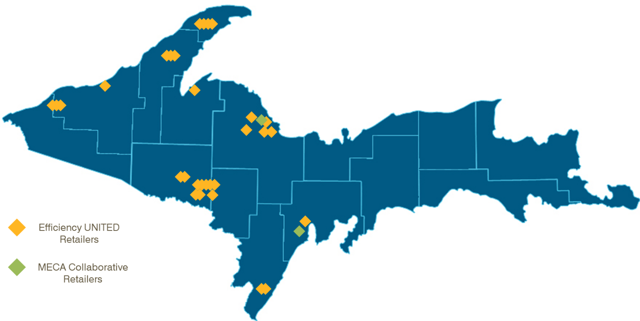
Source: PSC analysis of Web-based retailer search tools at www.efficiencyunited.com and www.michigan-energy.org.
Both program implementers offer mail-in rebates, particularly for larger measures, such as clothes washers or dishwashers. Product offerings and documentation requirements vary between implementers and in some cases, between utilities.
Under a Strategic Portfolio scenario, the program implementers would work to establish consistent product offerings, incentive strategies, and documentation requirements. Noting the challenges of retailer coverage, and increasing broadband access throughout the U.P., establishing an online store is increasingly feasible and could provide substantial benefits. These benefits include:
- Increased ability to track savings by utility
- Universal access for all U.P. residents in participating service areas
- Opportunity to educate consumers and provide information to help customers make purchase decisions based on individual needs and preferences
- Instant access to information about consumer preferences
- Ability to optimize product offerings based on consumer preferences, efficiency levels, and cost-effectiveness
An example of a regional online store serving multiple utilities is one offered by a collaborative group of utilities in Colorado operating under the name Efficiency Works. This online store provides extensive product information and advice to allow customers to select the most appropriate technologies. Manufacturer discounts can be stacked with available rebates, lowering the cost of the energy-efficiency measures to maximize benefits to both utilities and consumers. In addition to lighting and thermostat measures, this online store offers home automation technologies. Though these measures are not currently in the Michigan Energy Measures Database (MEMD), they are an important emerging technology that may expand future energy-efficiency potential.
A new initiative introduced by the U.S. Environmental Protection Agency, the agency that administers ENERGY STAR, is the ENERGY STAR Most Efficient 2018 distinction. This initiative identifies products that embody the highest levels of efficiency and technology innovation and provide the greatest savings to consumers. Through an online store, programs can provide information and structure incentives to encourage adoption of these most-efficient technologies.
An online store also creates an opportunity to develop a common identity for U.P. EWR initiatives. Delivering a program under a single banner can generate market momentum, increase consumer awareness, and simplify the process for accessing and choosing high-efficiency products. A centralized online store to serve U.P. customers provides increased leverage to negotiate favorable pricing for technologies and a mechanism for passing on savings directly to consumers.
Exhibit B-4 identifies impacts and costs for a Business as Usual scenario and for a peninsula-wide Strategic Portfolio scenario. The high-efficiency products program is historically one of the most cost-effective programs, delivering savings at a cost of conserved energy (CCE) of approximately $0.02 per kWh., Program enhancement activities would be focused on improving the ease of program participation, expanding program reach, and increasing savings diversity, i.e., increasing savings from nonlighting measures, which are currently the standard. Under the Strategic Portfolio scenario, enhancement activities result in a small increase in the CCE from the Business as Usual scenario but create increased savings opportunities and improved program sustainability in the long run.
Exhibit B-4: High-efficiency Products Program
 | Business as Usual | Strategic Portfolio
Annual savings (MWh) | 8,962 | 10,754
Annual expenditure (in thousands) | $1,364 | $1,773
Cost of conserved energy | $0.0210 | $0.0227
Source: Public Sector Consultants analysis.

Contractor-driven Programs (Equipment and Envelope Programs)
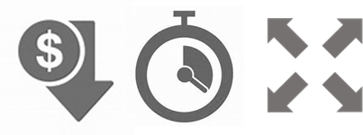
Space conditioning and water heating often account for a substantial portion of energy consumption for residential consumers. Space conditioning consumption is affected by the type, efficiency, condition, and size of equipment; the thermal integrity of the building; and the setting of temperature (manually or through use of system controls) to balance comfort, health, and efficiency. EWR related to space conditioning can be achieved through low-cost measures and occupant behavior changes, but the largest savings opportunities involve installation of equipment (e.g., furnaces, heat pumps, water heaters, air conditioners) or building envelope improvements (e.g., installation of insulation or windows). Similarly, water heating savings can be captured through equipment upgrades, installation of hot water savings devices, and changes in behavior.
Equipment and envelope upgrades are often done by a contractor that has the training, tools, and experience to perform this work with adherence to stringent quality and reliability standards. Residential customers often have long-standing relationships with these contractors and may reach out to them first when considering equipment or structural upgrades. During these early interactions, trade allies can influence the likelihood that a customer will select high-efficiency equipment and participate in a program.
To leverage the relationships of contractors and utility customers, leading EWR programs include a strong trade ally network. In exchange for program support and promotion, participating trade allies receive benefits, including:
- Financial incentives
- Technical support and training that focus on industry best practices
- Promotion on utilities’ websites and referrals
- Access to program marketing support materials
- Early notification and input into program activities and changes
Utilities can track trade allies’ quality of work and customer satisfaction and use that information to prioritize leads and referrals. As utilities and program implementers build trade ally network capacity, opportunities to negotiate prices and to introduce new technologies are created.
Often, when new measures come to market, prices are higher than they would be once market saturation is reached. Some utilities have successfully worked with equipment manufacturers and contractors to offer new technologies (e.g., tankless and heat-pump water heaters, ductless heat pumps, cold-climate air-source heat pumps) at prices that reflect discounts from manufacturers and contractors as well as utility rebates to stimulate demand and demonstrate the performance capabilities of these new technologies. Training and technical support help contractors gain familiarity with new technologies and aspects of quality installation that ensure savings realization.
The process of making equipment or home envelope improvements often begins with comprehensive home audit or residential energy assessment. In the U.P., there is a home energy audit contractor on the Efficiency UNITED website and one on the MECA Collaborative website. There are heating and cooling contractors, electricians, and plumbers listed on these sites as well, but no specific information about contractor performance or the types of qualifying measure that they install. Even with available contractors located in the U.P., there are still some contractors that travel from the Lower Peninsula to conduct work, increasing the cost of efficiency upgrades. Increasing the local availability of trade allies can further reduce cost of efficiency investments as travel time is often charged to customers.
Developing a consistent set of program offerings with a network of qualified and engaged trade allies will provide cost savings opportunities, increase ease of participation, expand geographic coverage, and allow for introduction of an expanded range of technologies. Exhibit B-5 identifies impacts and costs for a Business as Usual scenario and for an enhanced delivery program. Program enhancement activities would be focused on strengthening the trade ally network, introducing new technologies, and expanding service throughout the peninsula. Infrastructure investments would be offset by program efficiencies and opportunities to reduce measure cost through increased market saturation and opportunities to negotiate prices.
Exhibit B-5: Residential Equipment and Envelope Upgrades
 | Business as Usual | Strategic Portfolio
Annual savings (MWh) | 1,677 | 1,845
Annual expenditure (in thousands) | $714 | $857
Cost of conserved energy | $0.0447 | $0.0488
Source: Public Sector Consultants analysis.

Direct-delivery Programs
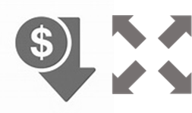
Direct-delivery programs include installation of measures for income-qualified and multifamily households and appliance recycling. They are often targeted to customers that are considered hard to reach that may not otherwise be able to take advantage of EWR offerings. Direct-delivery programs sometime utilize program implementer staff, contractors, or a mix of these to install EWR measures at low or no cost to the customer. Measures include lighting, hot water savings devices, infiltration reduction, and others. In some cases, the onsite visit begins with an assessment of energy savings opportunities.
A critical consideration with direct-delivery programs is to avoid lost opportunity savings. Often, the cost of sending an installation team onsite represents a significant portion of the delivery cost. In order to maximize cost-effectiveness, as many EWR improvements as possible must be made while onsite. Onsite visits also present an opportunity to collect customer information and housing characteristics that help to inform baseline conditions from which energy savings opportunities are measured.
Typically, utilities bear the full measure cost for EWR upgrades made for hard-to-reach customers, as those customers are sometimes unable (in the case of income-qualified customers) or unwilling (in the case of landlords or multifamily property managers) to contribute to project costs themselves. There are federal and state programs designed to encourage energy-efficiency investment for these hard-to-reach customers, and leveraging these funding opportunities can reduce the cost to utilities and ratepayers or can allow expanded services in these households to make significant and lasting efficiency improvements that reduce the energy burden of vulnerable customers.
Direct-delivery programs can be enhanced in a number of ways, including:
- Negotiating equipment costs and quality—if utilities standardize measure offerings with wide applicability and use their collective buying power, they can ensure that they get the best products at the best price
- Seeking additional funding sources or leveraging other investments, e.g., weatherization or home rehabilitation to maximize impact for individual households
- Capturing all possible savings while onsite, as it is costly to send crews to customers’ homes
- Capturing baseline customer characteristic information while onsite (building stock, equipment characteristics to inform potential analysis, targeting strategies, savings calculations, etc.)
Currently, appliance recycling is a direct-delivery program. With major efficiency upgrades for refrigerators adopted in 1994, the stock of inefficient refrigerators is diminishing. Utilities may consider including additional technologies (e.g., room air conditioners and dehumidifiers) for which early retirement would allow customers to upgrade to high-efficiency options.
Exhibit B-6 identifies impacts and costs for a Business as Usual scenario and for the Strategic Portfolio scenario where enhanced delivery approaches are adopted.
Exhibit B-6: Direct-delivery Programs
 | Business as Usual | Strategic Portfolio
Annual savings (MWh) | 2,406 | 2,587
Annual expenditure (in thousands) | $697 | $751
Cost of conserved energy | $0.0399 | $0.0400
Source: Public Sector Consultants analysis.

Information and Behavior-based Programs
Both Efficiency UNITED and the MECA Collaborative offer online audits as well as a suite of other educational initiatives.
Behavior-based programs are a cost-effective tool for EWR and can help ensure persistence of savings from other programs. Programs leveraging insights from academic research in behavioral science, economics, and psychology can also help improve the performance of traditional efficiency programs. For example, a recent study estimated that even if energy-efficient residential lighting technology is in place, there is still approximately 11 percent waste due to occupant behavior. Key considerations related to behavior-based savings include:
- Enabling access to energy usage data. As advanced metering technologies are implemented across utilities, many are utilizing the data to provide customers with a better understanding of how and when they use energy.
- Incorporating behavioral insights into program design. The application of behavioral research can drive better programs that may be able to achieve more savings or increase participation rates with the application of behavioral science principles.
- Measuring savings from behavior-based efficiency programs. Large-scale, behavior-based energy-efficiency programs are a relatively new strategy for acquiring savings. Rigorous evaluation methods are needed to generate savings estimates from these programs with confidence; verify savings validity; and understand issues, such as savings persistence.
Exhibit B-7 shows the Business as Usual and Strategic Portfolio scenarios for the information and energy education services. These programs have a higher cost of conserved energy when compared to other initiatives, but these programs can serve as a conduit to other programs, supporting additional participation and savings.
Exhibit B-7: Information and Energy Education Services
 | Business as Usual | Strategic Portfolio
Annual savings (MWh) | 882 | 1,234
Annual expenditure (in thousands) | $232 | $301
Cost of conserved energy | $0.0540 | $0.0501
Source: Public Sector Consultants analysis.

Commercial and Industrial Programs
A comprehensive energy-efficiency portfolio for commercial and industrial customers would include the following elements:
- Program(s) targeted to small businesses that address the particular barriers facing these entities
- Prescriptive rebates for EWR measures that have wide applicability
- Custom rebates for unique applications of EWR technologies specific to business facilities, processes, and energy use characteristics
- Strategic energy planning that engages the largest customers in long-term planning for EWR investments.
Both the Efficiency UNITED and the MECA Collaborative programs include prescriptive and custom rebates for commercial and industrial customers, and these programs contribute the largest savings for both program implementers (55 percent). An enhanced program portfolio would include existing elements as well as features targeted to the needs of the smallest and largest business customers.
Exhibit B-8 shows which portfolio-level strategies are applicable for each program type.
Exhibit B-8: Commercial and Industrial Program Strategies
Program Areas | Consistent Program Design | U.P.-focused Trade Ally Network | Strategic Purchasing | Centralized Administration | Leveraged Investment
Small-business direct installation | √ |  | √ | √ | √
Prescriptive rebates | √ | √ | √ | √
Custom rebates |  | √ |  | √ | √
Strategic energy management | √ | √ |  | √
Source: Public Sector Consultants

Small-business Direct Install
Small-business owners face special challenges accessing energy efficiency. With owners or managers often wearing multiple hats, they are unable to identify savings opportunities and rally the resources necessary to implement them. Small businesses are sometimes defined based on the size of their utility or on definitions for small businesses established by U.S. Small Business Administration.
Direct install programs can deliver energy-efficiency technologies that have wide applicability, such as lighting, controls, equipment tune-ups, and infiltration reduction, across different business or building types. Alternately, small-business programs may focus on a particular segment with higher energy use intensity, such as restaurants or grocery stores. Programs serving these types of businesses or buildings deliver an expanded set of measures, for example, food service equipment or refrigeration upgrades.
Small-business owners may pay for a portion of the EWR upgrades, but incentives may cover more than the typical half of measure costs. Installation costs may be paid up front through the program and the business owners pay their share after the work is done. There are funding sources available to assist small-business owners operating in rural areas, which can help advance EWR projects even when paying just a portion of the project cost is a barrier to participation.

Prescriptive and Custom Rebates
Commercial and industrial rebates generally fall into one of two categories: 1) prescriptive rebates that provide set incentives for a preset menu of technologies or measures or 2) custom incentives to business customers to install energy-efficient equipment in their existing facilities.
Prescriptive rebates are available for a wide range of technologies, including lighting; controls; heating, ventilation, and air conditioning (HVAC) equipment; building envelope; refrigeration; motors; and variable-speed motor drives. Equipment characteristics, i.e., efficiency levels, useful life, cost, and savings impacts, are often defined in the MEMD, and savings and incentives may vary based on operating characteristics, such as hours of operation. Prescriptive rebate applicants may work with a contractor or procure and install equipment themselves.
Custom incentives allow for the installation of innovative or unique applications of EWR technologies. Typically, these incentives are calculated based on projected kWh or Ccf savings, up to a maximum percentage of project costs. Custom projects are often large, and savings estimates are developed or reviewed by an engineering team. Assessing the accuracy of these savings estimates through rigorous monitoring and verification is critical to ensure both the utility and customer are realizing the expected savings. Some programs are starting to reserve a portion of incentives until actual savings can be measured and verified over time.
Similar to the residential equipment and envelope upgrade programs, commercial and industrial rebate programs rely heavily on trade allies. Efforts to engage trade allies through consistent program design, training opportunities, introduction of new technology, cost management, lead generation and other marketing support, and quality assurance efforts help to promote program success for customers, utilities and program implementers, and the trade allies themselves.

Strategic Energy Management
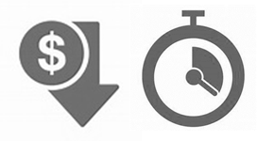
Strategic energy management (SEM) is a process of evaluating existing energy management business practices and implementing opportunities to optimize energy use at industrial and manufacturing companies. SEM applies the principles of continuous improvement to energy management to create a holistic approach to managing energy that fosters long-term savings.
Similar to Building Operator Certification (BOC), SEM provides training of company employees and supports them through the process of establishing and implementing an SEM system. EWR is integrated with business processes and is reinforced with feedback systems and continued learning. Participants learn to:
- Measure and track energy use to help inform strategic business decisions
- Drive managerial and corporate behavioral changes around energy
- Identify EWR opportunities specific to the needs and operations of their organization
- Develop the mechanisms to track and evaluate EWR efforts
Industrial energy consumption accounted for over half the energy consumption in the U.P. in 2016, compared to 27 percent of the statewide load. The dominance of industrial loads, many with unique energy use applications, makes SEM particularly applicable in the U.P. SEM plans allow a customer to identify progressive savings opportunities, and savings from early EWR investments can fund future EWR projects that can be planned around other facility upgrades (e.g., expansion of production capacity) or equipment life expectancy.
Because process efficiency improvements in large facilities often require specialized expertise, a benefit of SEM is that resources can be identified and reserved in advance. Long-term planning allows participants to optimize incentive funding and to identify alternative funding sources, including grant funding available to demonstrate advanced energy technologies.
The opportunities for enhancing and expanding the commercial and industrial programs include:
- Address additional challenges faced by small businesses with direct install assistance
- Negotiate equipment and installation costs when possible
- Seek additional funding sources or leverage other investments (e.g., funding for economic development or technology advancement)
- Unify program offerings
- Expand trade ally network by geography and skill level and ensure engineering expertise is available to assess project feasibility and savings
- Institute an SEM process with the largest industrial customers to create systematic and long-term EWR plans
Exhibit B-9 shows the projected average annual savings and expenditures over a ten-year period for a Business as Usual scenario and the savings and cost implications of implementing the Strategic Portfolio opportunities.
Exhibit B-9: Commercial and Industrial Portfolio
 | Business as Usual | Strategic Portfolio
Annual savings (MWh) | 17,681 | 20,156
Annual expenditure (in thousands) | $2,840 | $3,777
Cost of conserved energy | $0.0221 | $0.0258
Source: Public Sector Consultants analysis.

Overall Cost and Savings
The residential and commercial and industrial programs discussed herein combine to become a comprehensive EWR portfolio for either a Business as Usual scenario or a Strategic Portfolio scenario as shown in Exhibit B-10. These cost and savings estimates are based on historical achievements, industry standards, and expected impacts of the suggested portfolio strategies. In some cases, these strategies reduce cost through preferential pricing and program efficiencies. For other programs, investment in infrastructure is required to reach more customers or provide deeper savings for customers already engaged in the programs. These impacts and costs would be reviewed through a collaborative planning process engaging utilities and program administrators, as well as stakeholders and customers.
Exhibit B-10: Business as Usual and Strategic Portfolio Impacts and Cost
 | Business as Usual |  | Strategic Portfolio
 | Annual Savings (MWh) | Annual Expenditure (in thousands) | Annual Savings (MWh) | Annual Expenditure (in thousands)
High-efficiency products | 8,962 | $1,364 | 10,754 | $1,773
Residential equipment and envelope upgrades | 1,677 | $714 | 1,845 | $857
Direct-delivery programs | 2,406 | $697 | 2,587 | $751
information and education services | 882 | $232 | 1,234 | $301
Commercial and industrial portfolio | 17,681 | $2,840 | 20,156 | $3,777
Pilot programs | 1,217 | $330 | 1,217 | $330
Total | 32,825 | $6,177 | 37,793 | $7,789
 | Business as Usual |  | Strategic Portfolio
Portfolio cost of conserved energy per kWh | $0.0259 |  | $0.0284
Portfolio benefit/cost ratio (utility cost test) | 2.75 |  | 3.0
Source: Public Sector Consultants analysis.
Business as Usual currently provides substantial benefits to U.P. utilities and customers, and the identified programs provide an annual average electric savings of 32,825 MWhs (enough power to serve over 5,000 average households in the U.P.). The Strategic Portfolio scenario, however, even with a slightly higher cost of conserved energy, is more cost-effective, provides nearly 38,000 MWhs of energy savings, and is positioned to capture additional nonenergy benefits. Alongside cost-effective energy savings, the Strategic Portfolio approach is designed to support learning opportunities for U.P. residents and businesses and empower them to manage their energy costs, promote economic and community development throughout the region, draw outside investments in U.P. facilities, and drive greater customer engagement. This scenario analysis focuses on electric savings, but similar benefits are available for natural gas programs as well.

230 N. Washington Square
Suite 300
Lansing, MI 48933

Clean, Renewable and Efficient Energy Act of 2008. (2008). PA 295. Accessed December 1, 2017. http://legislature.mi.gov/doc.aspx?mcl-act-295-of-2008
Clean and Renewable Energy and Energy Waste Reduction Act. (2016). PA 342. Accessed December 1, 2017. https://www.legislature.mi.gov/documents/2015-2016/publicact/htm/2016-PA-0342.htm
The City of Wakefield, an electric municipal utility in the U.P, and DTE Energy, a dual-fuel utility that provides natural gas service in the U.P., implement programs independently. SEMCO Energy, a natural gas utility with service areas throughout Michigan, including the U.P., has contracted with Efficiency UNITED to deliver programs throughout its service territory but has not chosen the statewide program administrator as an alternate compliance path for achieving energy optimization/energy waste reduction targets. For the 2018–2019 program years, the Upper Peninsula Power Company began contracting directly with Efficiency UNITED to implement programs rather than utilizing the alternate compliance path. Our analysis to date focused on the work of the two program implementers, Efficiency UNITED and the MECA Collaborative.
PA 295, Section 91.
Efficiency UNITED. n.d. 2016 Annual Report. Accessed January 4, 2018. http://www.michigan.gov/documents/mpsc/2016_Efficiency_UNITED_Annual_Report_Final_560510_7.pdf
Estimated U.P. targets are calculated for SEMCO and DTE Energy by multiplying reported U.P. natural gas sales by 0.75 percent, the savings target established for natural gas in PA 295, as amended by PA 342.
GDS Associates. August 9, 2017. Upper Peninsula Energy Efficiency Potential Study Final Report. Marietta: GDS Associates.
Net present value is the difference between the present value of cash inflows and the present value of cash outflows over a specified period of time. NPV is used in budgeting to analyze the profitability or cost-effectiveness of a projected investment or project.
GDS Associates. August 11, 2017. Michigan Lower Peninsula Electric Energy Efficiency Potential Study. GDS Associates. August 9, 2017. Upper Peninsula Energy Efficiency Potential Study Final Report. Accessed September 1, 2017. https://www.michigan.gov/mpsc/0,4639,7-159-80741---,00.html
California Public Utilities Commission. 2001. California Standard Practice Manual: Economic Analysis of Demand-Side Programs and Projects. Sacramento: California Public Utilities Commission. Accessed November 20, 2018. http://www.cpuc.ca.gov/uploadedFiles/CPUC_Public_Website/Content/Utilities_and_Industries/Energy_-_Electricity_and_Natural_Gas/CPUC_STANDARD_PRACTICE_MANUAL.pdf
http://aceee.org/sites/default/files/publications/researchreports/E086.pdf
http://aceee.org/research-report/u1606
Energy Optimization. 2018. “Cloverland Electric Cooperative: Efficient HVAC.” Energy Optimization. Accessed February 12, 2018. https://www.michigan-energy.org/utility/Cloverland
Efficiency UNITED. March 2018. Space Heating and Cooling Rebate Application. Accessed April 1, 2018. https://efficiencyunited.com/_/documents/eu-heating-cooling-application.pdf
The EnergySmart Grocer program, offered in multiple locales across the U.S., provides a model for negotiating pricing for a suite of measures applicable to grocery stores, with local contractors serving that market. The program allows for low-cost, low-hassle installation of EWR measures and creates a business opportunity for the participating contractors.
CLEAResult. 2015. “EnergySmart Grocer.” EnergySmart Grocer. Accessed March 13, 2018. http://www.energysmartgrocer.org/
United States Department of Agriculture and Rural Development. 2018. “Rural Energy for America Program: Renewable Energy Systems and Energy Efficiency Improvement Loans and Grants.” United States Department of Agriculture and Rural Development. Accessed March 9, 2018. https://www.rd.usda.gov/programs-services/rural-energy-america-program-renewable-energy-systems-energy-efficiency
United States Department of Health and Human Services. 2018. “Low-income Home Energy Assistance Program (LIHEAP).” Office of Community Services. Accessed May 1, 2018. https://www.acf.hhs.gov/ocs/programs/liheap
United States Department of Energy. n.d. “Funding Opportunities.” United States Department of Energy Office of Energy Efficiency and Renewable Energy. Accessed May 1, 2018. https://www.energy.gov/eere/funding/eere-funding-opportunities
Lisa Bowers. May 13, 2018. “NMU Program Expands Broadband Access in Upper Peninsula.” The Daily News. Accessed May 15, 2018. http://www.ironmountaindailynews.com/news/local-news/2017/04/nmu%E2%80%88program-expands-broadband-access-in-upper-peninsulanmu%E2%80%88program-expands-broadband-access-in-upper-peninsula/
Efficiency Works. 2018. “Store.” Efficiency Works. Accessed May 1, 2018. https://efficiencyworksstore.com/
Michigan Public Service Commission. 2018. “Michigan Energy Measures Database.” Department of Licensing and Regulatory Affairs. Accessed February 21, 2018. https://www.michigan.gov/mpsc/0,4639,7-159-52495_55129---,00.html
ENERGY STAR. 2018. “ENERGY STAR Most Efficient 2018.” ENERGY STAR. Accessed May 1, 2018. https://www.energystar.gov/products/most_efficient
The cost of conserved energy is an investment statistic that simplifies comparison between conservation measures and against competing energy supplies. A formula for calculating the cost of conserved energy formula is presented. A conservation measure is cost-effective if its CCE is less than the cost that would be incurred to supply the energy the measure displaces.
A.K. Meier. 1984. “The Cost of Conserved Energy as an Investment Statistic.” OAKTrust. Accessed May 24, 2018. http://oaktrust.library.tamu.edu/handle/1969.1/94751
Opinion Dynamics. March 20, 2013. ComEd Residential and C&I Saturation/End-use, Market Penetration, and Behavioral Study. Accessed May 1, 2018. http://ilsagfiles.org/SAG_files/Meeting_Materials/2013/March%2019-21,%202013%20Meetings/March%2020,%202013%20Meeting/ComEd%20End%20Use%20Saturation%20Study%20(Bill%20Norton,%20Opinion%20Dynamics).pdf
U. S. Small Business Administration. n.d. Table of Small Business Size Standards Matched to North American Industry Classification System Codes. Accessed May 1, 2018. https://www.sba.gov/sites/default/files/files/Size_Standards_Table.pdf
United States Department of Agriculture and Rural Development. 2018. “Rural Energy for America Program: Renewable Energy Systems and Energy Efficiency Improvement Loans and Grants.” United States Department of Agriculture and Rural Development. Accessed March 9, 2018. https://www.rd.usda.gov/programs-services/rural-energy-america-program-renewable-energy-systems-energy-efficiency
Building Operator Certification (BOC) is a training and certification program for building operators and facility managers that offers combined classroom and online instruction that, merged with hands-on projects, transfer into reduced building operational and energy expenses, extended longevity of building equipment, and a skilled workforce. The Michigan Agency for Energy has offered discounts for participants enrolling in BOC trainings offered throughout the state. BOC training has not been offered in the U.P.
United States Energy Information Administration. November 9, 2017. "2016 Utility Bundled Retail Sales—Residential." Electricity: Electric Sales, Revenue, and Average Price. Accessed February 6, 2018. https://www.eia.gov/electricity/sales_revenue_price/pdf/table6.pdf

