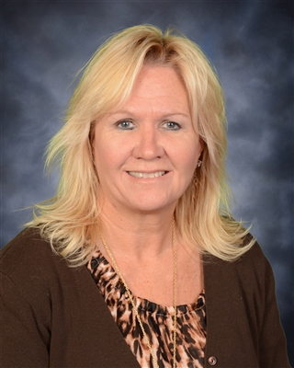

Marlene F. Mottes

Ms. Mottes, was formally an at-home mom for 10 years enjoying raising her 3 children and being actively involved in her Iron County, MI community of which she was named “Community Minded Women of the Year” in 1994.

She then spent 11 years as the Crime Victim’s Rights Coordinator for the Iron County Prosecuting Attorney’s office and Victim Services Program Coordinator for the Volunteer Victim Advocate Program she developed for the Iron County Sheriff’s Department. During this time she was named by Senator Carl Levin as the “Crime Fighting Mom of the Year” in 2003.

In 2005 she exited the criminal justice system to take the position of 4K-12 School Counselor/Dean of Students at the Beecher Dunbar Pembine School District in Pembine, Wisconsin until March of 2017, but continued to be involved in Victim Services as a volunteer and board member for the Caring House, Inc. in Iron Mountain while employed there.

Eventually she found her way back into Victim Services in 2017 for a position with the Department of Justice US Attorney’s Office Western District of Michigan as a Victim Advocate handling all victim crimes with special time and consideration dedicated to Indian Country Victim issues and prevention and awareness teaming with UP providers including Indian Country.

In this new role, she has been requested to assist with several initiatives including the Human Trafficking Task Force re-development, Sexual Assault Nurse Examiner Programs (SANE), and Opioid education and prevention campaign. She is currently the UPHTTF Group Leader/Administrator.

Her office is located in Marquette and she can be reached on her direct line at 906-226-1422 or by email at marlene.f.mottes@usdoj.gov.

